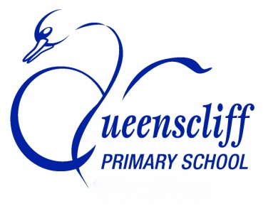
A JOINT SCHOOL INITIATIVE

Borough of Queenscliffe
A Community Poem

Queenscliff Primary School and Pt Lonsdale Primary School have teamed up to create the Borough’s first ever ‘long poem’.
The two schools will be kick-starting the process by inviting each of their students to contribute 1-2 lines of verse concerning what they love most about the Borough.
In addition, the schools would like to invite community members, including local businesses, volunteer, community and government organisations to contribute 1-2 lines to the poem.
Long poems are an important means of collective expression. They often function to tell a "tale of the tribe," or a story that encompasses a whole community’s values and history.
For us, this long poem is part of both schools’ efforts to re-weave the threads of our community, one story at a time.
If you would like to be part of this exciting initiative, our schools would love to receive your contributions. Simply fill in the form below and drop it in to either school.
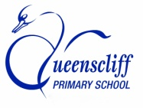
Two lines of verse:
____________________________________________________________________________________________________________________________________________________________________________________________________________________________________________________________________________________________________________________________________________________________________________________
Name/Organisation/Business:_______________________________________________________________________________________________________________________________________________________
_____________________________________________________________________________________________
Thank you for being part of the Borough’s first ever community ‘long poem’

